**Report on Running Jitsu Using Docker Commands**

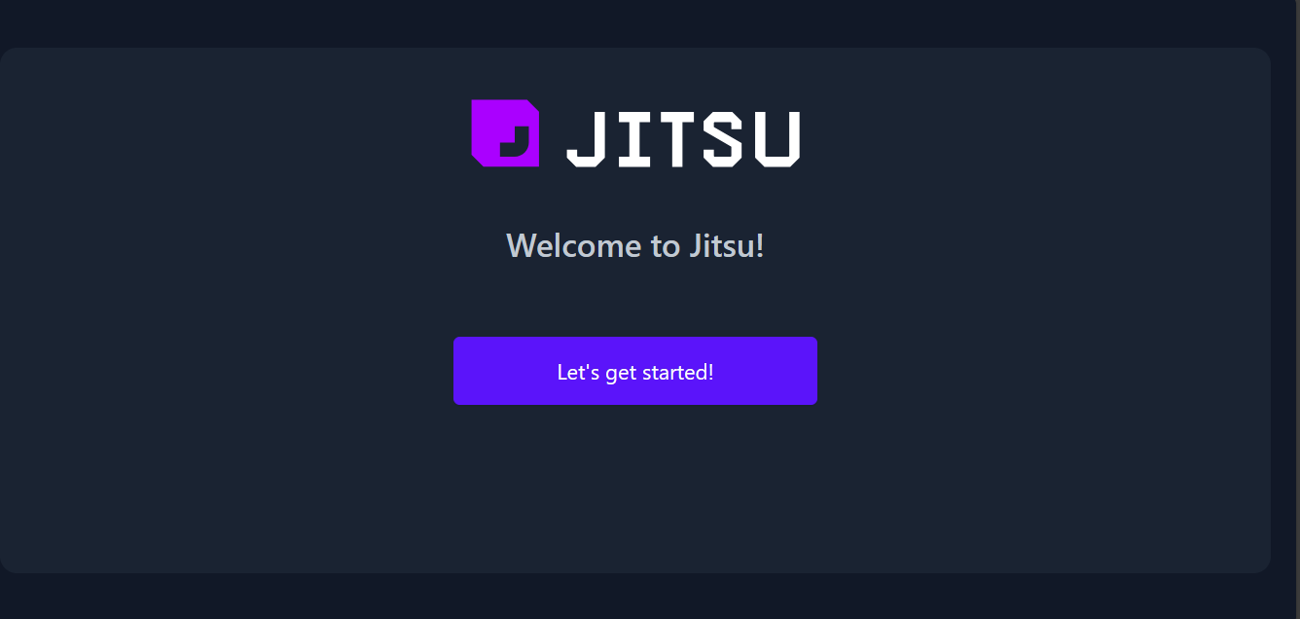

**Command**

docker run --name some-redis -d redis

**Description**

This command runs a Redis container in detached mode and names it "some-redis".

Inspecting Docker Container

**Command**

docker inspect -f '{{range .NetworkSettings.Networks}}{{.IPAddress}}{{end}}' 172db6e6f018